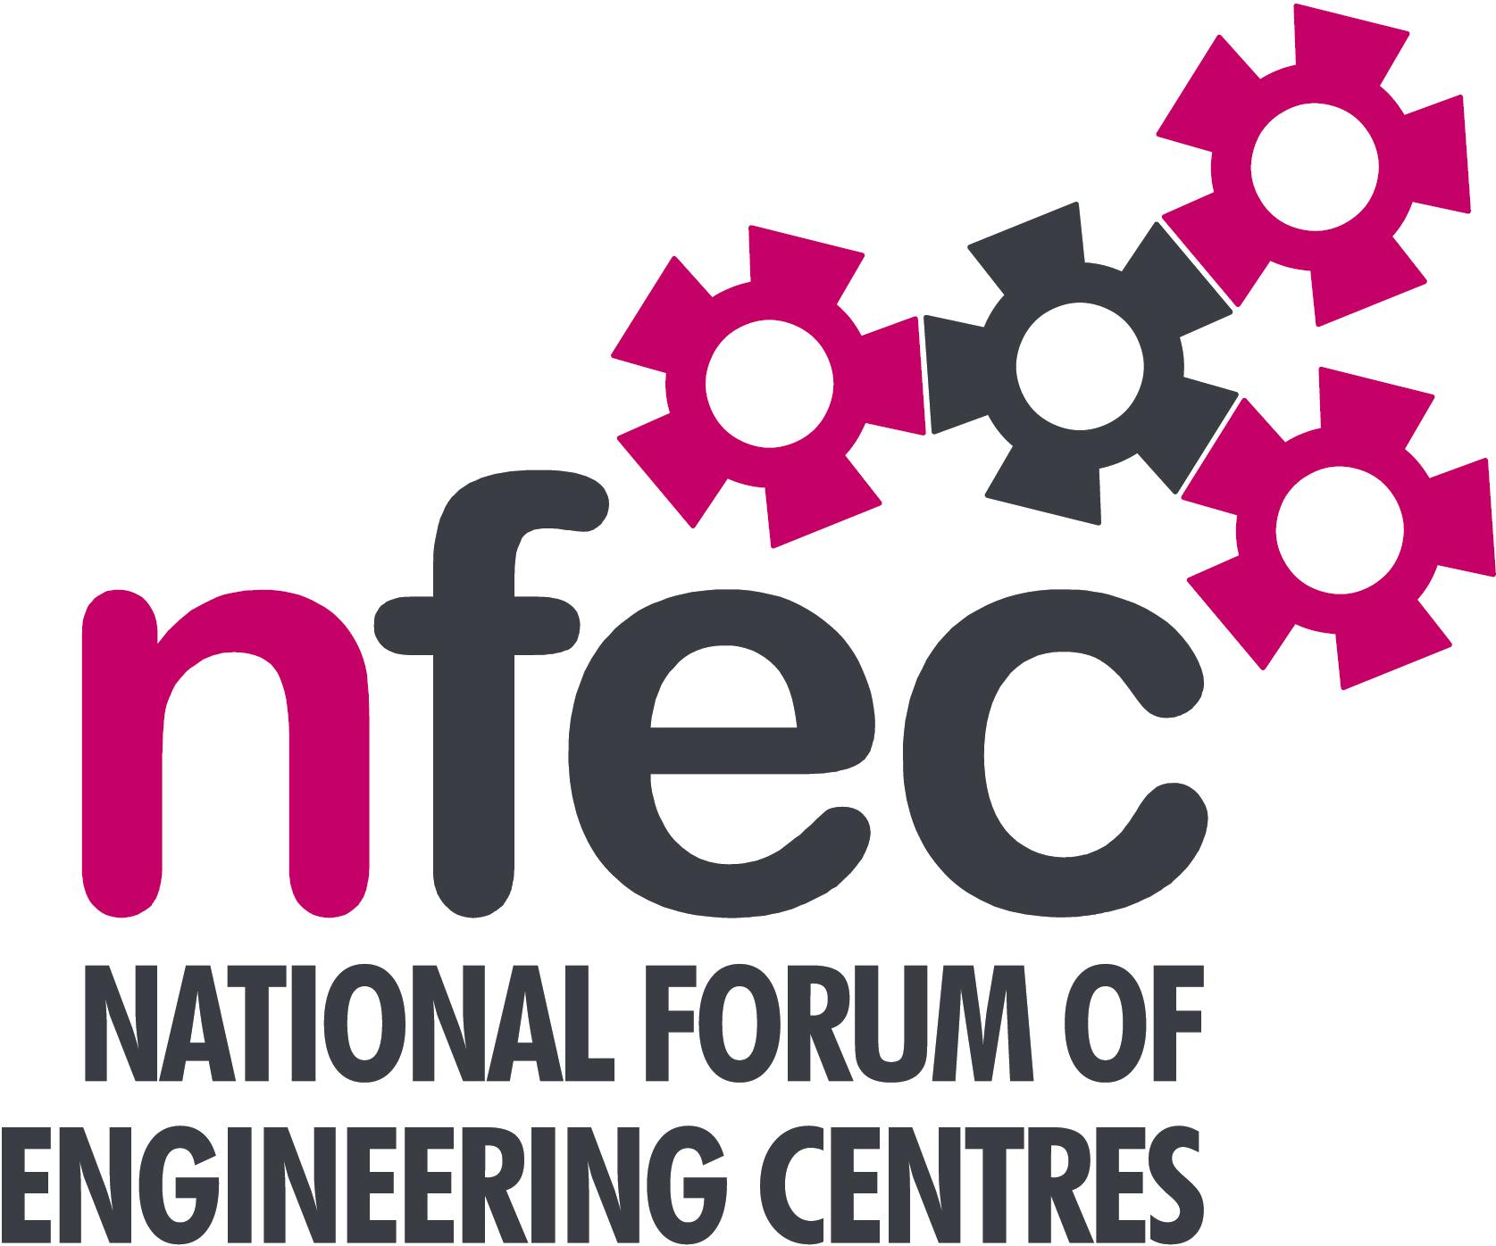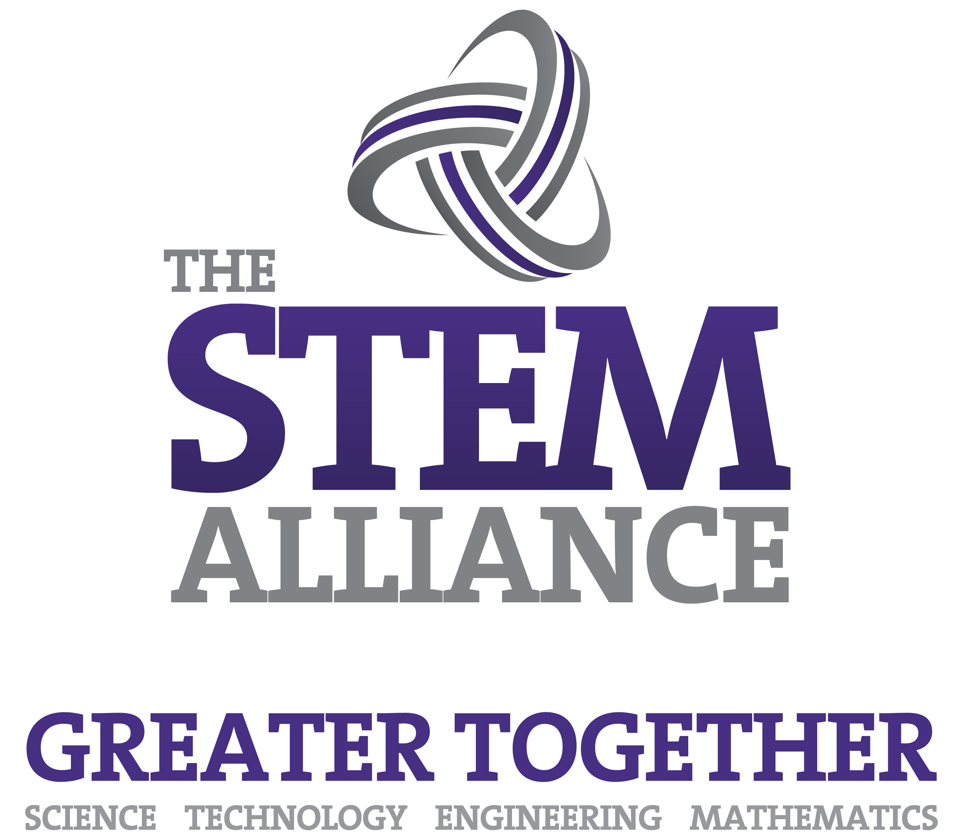
NFEC Winter 2016
South West Regional Seminar

Monday 25th January 2016, 10.15am - 15.00 (Coffee from 10am)
Venue: Petroc, Barnstaple Campus, Old Sticklepath Hill, Barnstaple, Devon
EX31 2BQ

Telephone Number: 01271 345291

Programme

- Welcome and Introduction to the Seminar | Bob Coombes (South West Regional Coordinator and Petroc) | 10.15
- Current matters of concern relating to quality, content, structure, management and delivery of programmes of training and education in Engineering (not included on Agenda) - an opportunity for open discussion with a focus to distill key issues and plans for addressing them. | All Delegates/Bob Coombes | 10.25
- The Welding Institute in the South West - World Skills and Current Trends in Welding regulations  - Qualifications and Awarding Bodies – Current developments and general issues  Lunch & Demonstrations by Exhibitors  - West of England Sector skills statement for Advanced Engineering & Aerospace from our annual business skills survey data  - Aprenticeship Traiblazer Initiative - Update on Trailblazer Developments and related issues  - Tour of the Engineering Facilities  - Date, Place and Topics for next Seminar  - Seminar Closes. | Hugh McPhillips, GETS Training  EAL - Bill Lockyer  Edexcel - Bridget Stait  C&G – Andrew Hewison tbc  Logic Certification - Tracy Harker  AQA – Phillip Bryant  Pearl Mills, West of England Local Enterprise Partnership  Bob Coombes on behalf of Bob Millington  Petroc | 10.40  11.40  12.15  13.00  13.45  14.30
Entry is free to this seminar for members or non-members present for a first attendance.There will be a charge for non members after this. A light buffet lunch will be provided and you will be able to see/discuss demonstrations of the latest available equipment and facilities for the delivery of learning in Engineering | To book your place:  Email: admin@nfec.org.uk  Phone: 07759 901229

